July 2015
Float Like a Butterfly at the Zilker Botanical Garden

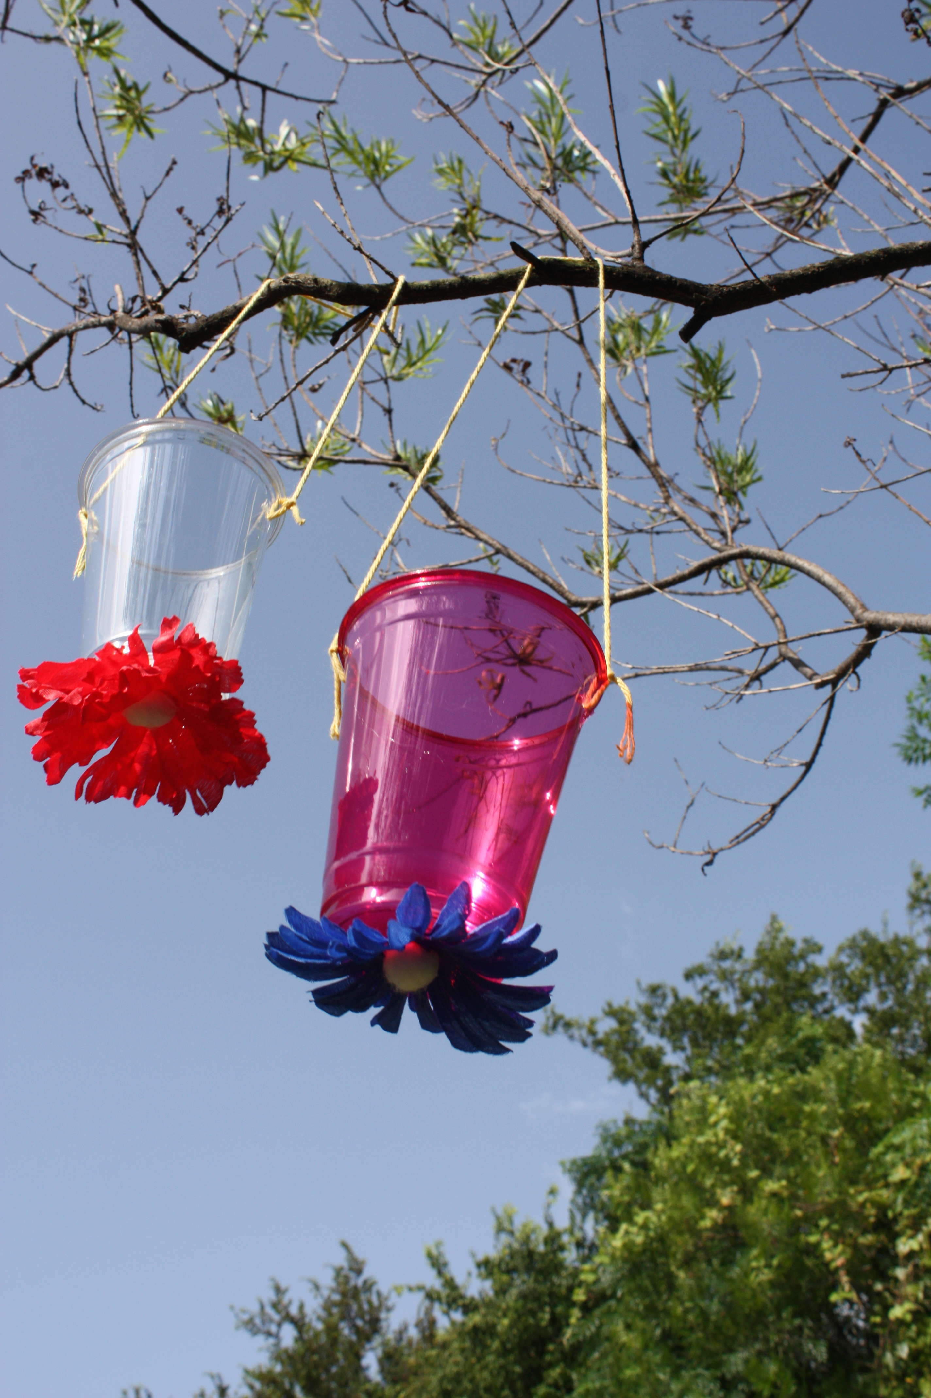
MAKE A BUTTERFLY FEEDER

Butterflies drink nectar, a sweet liquid, from flowers. They use a long tube called a proboscis to drink the nectar from inside the flower, like when you drink juice from inside a cup using a straw. Here, we’ll make a butterfly feeder that looks like a flower and contains “nectar” for butterflies to drink.

Materials:

(included)  Plastic cup  Piece of string  Cotton ball  Flower petals | (from home)  Scissors  Glue  Water  Sugar
Instructions:

- Use your scissors to make two small holes on opposite sides of the rim of the plastic cup. Tie your string through the holes to make a hanger.
- Use your scissors to make a small hole in the bottom of the cup. Push the cotton ball into the hole so that half is inside the cup and half is poking out the bottom.
- Pick petals from your flower and glue them to the cup around the cotton ball in the shape of a flower.
- Make flower “nectar” by mixing one tablespoon of sugar into nine tablespoons of warm water and pour into the cup.
- Hang your butterfly feeder from a branch in your yard and watch for butterflies. Be sure to report back and tell us who visited your feeder.
- Hint: Remember to change the sugar water regularly and if you get unwanted guests, try placing plastic wrap around the top of the cup.

GROWING MILKWEED FOR MONARCH BUTTERFLIES

One of the butterflies we looked for in the garden was called a monarch butterfly. Monarchs are special because every year they migrate from southern Canada and the United States all the way to Mexico to spend the winter. Can you find those places on a map? That’s a long way to fly!

Milkweed is the only plant that monarch caterpillars will eat so without lots of milkweed around, we won’t have many monarchs. You can help the monarchs by planting milkweed in your garden and here’s a plant to get you started. Not only is milkweed great caterpillar food, it’s also a source of nectar for lots of different kinds of butterflies.

How to Care for your Tropical Milkweed

Tropical milkweed is native to Mexico and grows all around Central Texas. This variety does well in full sun or part shade and will grow up to two to four feet with yellow and orange blooms in the spring through fall.

You can plant your tropical milkweed in the ground or in a container. Water regularly when it’s a seedling, but your milkweed will be very drought tolerant once it is established in your garden. In Texas, it’s recommended to cut back established plants to the ground in the late fall to prevent disease and to encourage the monarchs to make their fall migration. You can also move your seedlings indoors until spring.

Be sure to check your milkweed for butterfly eggs (tiny and yellow) that grow into caterpillars that eat the leaves and for any butterflies that come by for lunch on the blooming flowers. And remember to let us know what you see!

If you want to expand your butterfly habitat, the National Gardening Association’s website for kids has a great article on how to plant a butterfly garden: http://www.kidsgardening.org/activity/plant-family-butterfly-garden.

